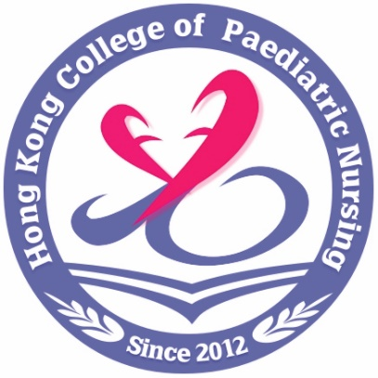
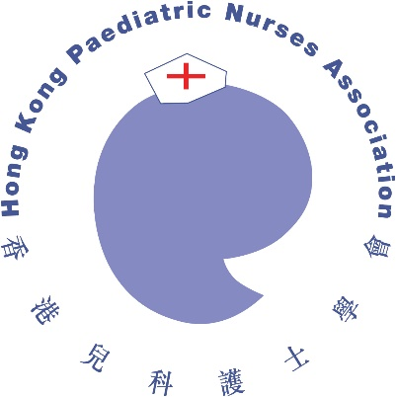

Joint Annual

Scientific Meeting 2026

The Hong Kong Paediatric Society,
Hong Kong Paediatric Nurses Association,
Hong Kong College of Paediatric Nursing,
&
Hong Kong Children’s Hospital
31st January 2026 (Saturday)

Venue (Physical Meeting): M Ground, Queen Elizabeth Hospital

All Healthcare Professionals are Welcome!
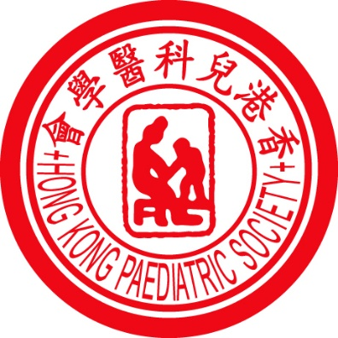


Instructions:

Abstract Form

- Abstract Form is available for download at http://medicine.org.hk/hkps
http://www.hkpna.com.hk
http://www.hkcpn.com
- Submitted abstracts should not have been published in any local or international journal in full paper form prior to the joint ASM.
- All accepted abstracts will be published in the Hong Kong Journal of Paediatrics as submitted, directly reproduced from the electronic submission.
- Table and graphics should be kept to a minimum and will not be published in the Journal.
- All abstracts must be submitted in WORD file via email conforming EXACTLY to the format of this Abstract Form.
- All abstracts must be in English, within the space allotted on the Abstract Form
- The abstract should be no more than 250 words, summarizing with the following headings: Background/ Introduction, Purpose, Methods, Findings, Conclusions
- The suggested font type and size is Times New Roman, 10/11 points. The abstract should be single line spacing.
- More than one abstract could be submitted.
- Provide the title of the paper in BOLD CAPITAL LETTERS.
- Provide name of author(s) followed by the name of the institution.
- Indicate the names of the authors according to the following format: Initials of given names without punctuation followed by family name. Underline the name of the presenting author.

Please tick in appropriate box

Title: Prof Dr Mr Ms Miss

Please type or print your name in CAPITAL letters.

Name:
Family Name

Given Name

Institution:

Profession:
Doctors / Postgraduate students / Medical students
Nurses / Allied health / other professionals

Email:

Mailing Address:

Telephone No.

Facsimile No.

Indicate preferred format of presentation:
Oral
Poster
Either oral or poster

Send your abstract form via email:
hkps.katie4@gmail.com

Deadline: 28th November 2025

